# GitHub Copilot Plans

## Individuals

|  |  |  |
| --- | --- | --- |
| **Plan** | **What's Included** | **Price** |
| Free | * 50 agent mode or chat requests per month * 2,000 completions per month * Access to Claude 3.5 Sonnet, GPT-4o, and more | $0 |
| Pro | * Unlimited agent mode and chats with GPT-4o * Unlimited code completions * Access to code review, Claude 3.7 Sonnet, o1, and more * 6x more premium requests to use latest models than Free, with the option to buy more | $10 |
| Pro+ | * Access to all models, including GPT-4.5 * 30x more premium requests to use latest models than Free, with the option to buy more | $39 |

## Businesses

|  |  |  |
| --- | --- | --- |
| **Plan** | **What's Included** | **Price** |
| Business | * Unlimited agent mode and chats with GPT-4o * Unlimited code completions * Access to code review, Claude 3.5/3.7 Sonnet, o1, and more * 300 premium requests to use latest models per user, with the option to buy more * User management and usage metrics * IP indemnity and data privacy | $19 |
| Enterprise | * Access to all models, including GPT-4.5 * 3.33x more premium requests to use latest models than Business, with the option to buy more * **Index an organization’s codebase for a deeper understanding** of the customer’s knowledge for more tailored suggestions and will offer customers access to fine-tuned custom, private models for code completion. | $39 |

Notes:

* The primary differences between the organization offerings and the individual offering are license management, policy management, and IP indemnity.
* For up-to-dated and detailed plans for GitHub Copilot, check [here](https://docs.github.com/en/copilot/about-github-copilot/plans-for-github-copilot).

# How GitHub Copilot Extension Works

## How Does GitHub Copilot Generate Code Suggestion?

### In-Line Code Suggestion

To generate a code suggestion, GitHub Copilot extension begins by examining the code in your editor — focusing on the **lines just before and after your cursor**, but also information including **other files open** in your editor and the URLs of repositories or file paths to identify relevant context. That information is sent to GitHub Copilot’s model, to make a probabilistic determination of what is likely to come next and generate suggestions.

### In-Chat Code Suggestion

To generate a suggestion for chat in the code editor, GitHub Copilot creates a contextual prompt by combining your prompt with additional context including the **code file open** in your active document, your **code selection**, and general **workspace information**, such as frameworks, languages, and dependencies. That information is sent to GitHub Copilot’s model, to make a probabilistic determination of what is likely to come next and generate suggestions.

## What Personal Data Does GitHub Copilot Process?

GitHub Copilot processes personal data based on how Copilot is accessed and used. The types of personal data processed may include:

* **User Engagement Data**: This includes pseudonymous identifiers captured on user interactions with Copilot, such as accepted or dismissed completions, error messages, system logs, and product usage metrics.
* **Prompts**: These are inputs for chat or code, along with context, sent to Copilot's AI to generate suggestions.
* **Suggestions**: These are the AI-generated code lines or chat responses provided to users based on their prompts.
* **Feedback Data**: This comprises real-time user feedback, including reactions (e.g., thumbs up/down) and optional comments, along with feedback from support tickets.

## GitHub’s Data Protection Agreement

<https://github.com/customer-terms/github-data-protection-agreement>

## GitHub General Privacy Statement

<https://docs.github.com/en/site-policy/privacy-policies/github-general-privacy-statement>

# Supported IDEs and Platforms

## IDE Extension

* Code completion functionality: Visual Studio Code, Visual Studio, Vim, Neovim, JetBrains, Azure Data Studio.
* Chat functionality: Visual Studio Code, Visual Studio, JetBrains.

## Terminal

GitHub CLI and as a chat integration in Windows Terminal Canary.

# Setting Up GitHub Copilot

<https://docs.github.com/en/copilot/setting-up-github-copilot>

# Using GitHub Copilot

NOTE

This section focuses on GitHub Copilot on **Visual Studio Code only**. Please note that if you're working on other text editors or IDEs.

## Code Suggestion/Completion

### Getting Suggestions

Code suggestions are generated **as you type**. You can also describe something you want to do **within a code comment**, and Copilot will suggest the code (also called *Ghost Text*) to accomplish your goal.

To accept the suggestion, press Tab.

|  |  |
| --- | --- |
| JavaScript ghost text suggestion. | Use code comments to let Copilot generate a Student class in TypeScript with properties and methods. |

### Showing Alternative Suggestions

For any given input, Copilot may offer **multiple suggestions**. You can select which one to use, or reject all.

#### In-Line

**Hovering** over the suggestion shows the Copilot control for choosing suggestions. To display next or previous suggestions, click the 🡪 or 🡨 arrow button in the control.

You can also use keyboard shortcuts to show alternative suggestions:

|  |  |  |
| --- | --- | --- |
| **OS** | **See next suggestion** | **See previous suggestion** |
| macOS | Option (⌥) or Alt + ] | Option (⌥) or Alt + [ |
| Windows or Linux | Alt + ] | Alt + [ |

To accept a suggestion, click "Accept" in the Copilot command palette, or press Tab. To reject all suggestions, press Esc.

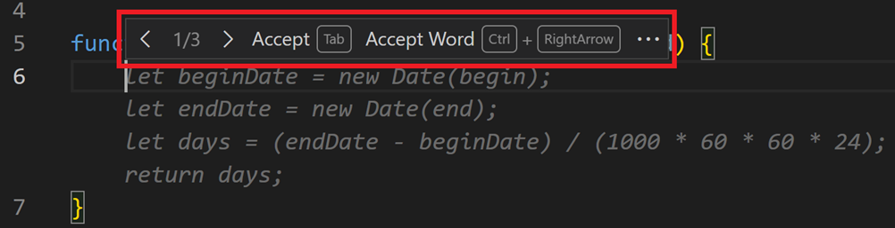

#### In-Tab

As Copilot showing suggestions, press Ctrl + Enter to open a new tab with multiple additional options.

To accept a suggestion, below the suggestion, click "Accept suggestion <NUMBER>". To reject all suggestions, close the Tab.

### Accepting Partial Suggestions

If you don't want to accept an entire suggestion from Copilot, you can accept the next word or the next line of a suggestion.

As Copilot showing suggestions, hover over the suggestion to show the Copilot control for choosing suggestions. To accept only the next word of the suggestion, click "Accept Word" in the control.

Alternatively, you can use a keyboard shortcut to accept the next word of a suggestion:

|  |  |
| --- | --- |
| **OS** | **Accept Next Word** |
| macOS | Command + → |
| Windows or Linux | Ctl + → |

If you want to accept the next line of a suggestion, you will need to set a custom keyboard shortcut for the command editor.action.inlineSuggest.acceptNextLine

### Next Edit Suggestions

Based on the edits you're making, Copilot NES both predicts the location of the next edit you'll want to make and what that edit should be.



Note: Need to enable Copilot NES via VS Code setting github.copilot.nextEditSuggestions.enabled.

### Enable or Disable Code Suggestions

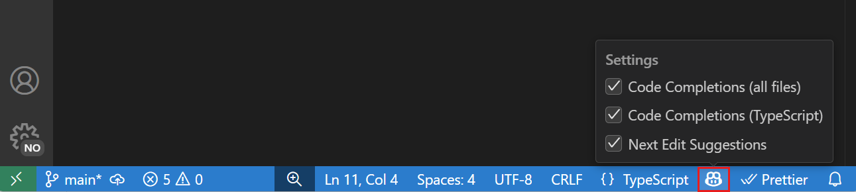

Alternatively, modify the github.copilot.enable setting in the Settings editor.

## Chat

### Chat Accesses

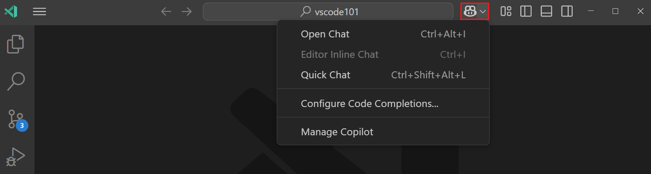

There are some ways to access chat in VS Code:

|  |  |  |  |
| --- | --- | --- | --- |
| **Chat** | **Shortcut** | **Description** | **Example** |
| **Chat view** | Ctrl+Alt+I | Have an ongoing, multi-turn chat conversation in a dedicated view. Switch between different chat modes at any time. | Copilot Chat view in the Secondary Side Bar and Explorer view in the Primary Side Bar. |
| **Inline chat** | Ctrl+I | Start a conversation directly from the editor (*Editor Inline Chat*) or integrated terminal (*Terminal Inline Chat*) to get suggestions in-place. | Screenshot of VS Code editor with the suggested code change.  Screenshot showing that you can ask complex questions like "list the top 5 largest files in the src dir" |
| **Quick chat** | Ctrl+Shift+Alt+L | Ask a quick question and get back into what you were doing. | Screenshot showing the Quick Chat view, containing the answer to the question "what is recursion". |

**Tips**:

* You can open a chat session as a separate editor tab, or even as a separate window. This allows multiple chat sessions open at the same time.

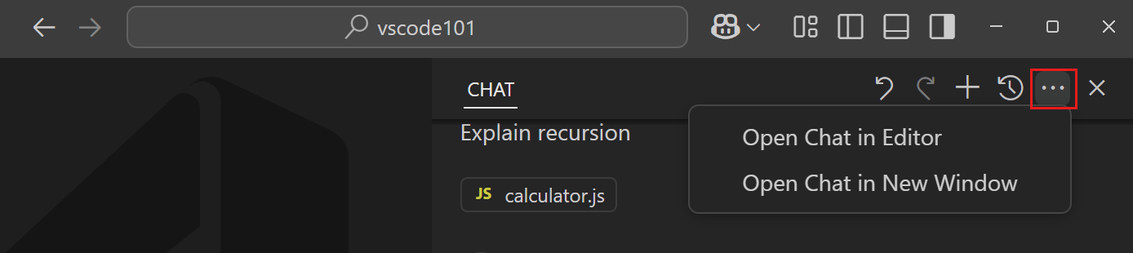

### Chat Modes

Based on your specific needs, you can choose between different modes of chat:

|  |  |
| --- | --- |
| **Mode** | **Description** |
| **Ask** | **Ask questions** about your codebase or technology concepts. |
| **Edit** | Make **edits across multiple files** in your codebase. |
| **Agent** | Start an agentic coding workflow.  Copilot **autonomously** plans the work needed and determines the relevant files and context. It then makes edits to your codebase and invokes tools to accomplish the request you made. Agent mode monitors the outcome of edits and tools and iterates to resolve any issues that arise.  <https://code.visualstudio.com/blogs/2025/02/24/introducing-copilot-agent-mode> |

Switch between chat modes using the *Mode* dropdown in the *Chat* view.

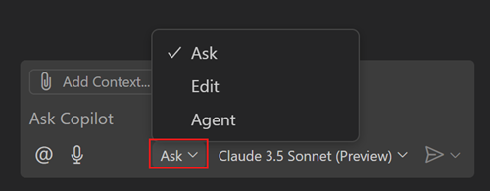

### Adding Chat Context

To help Copilot **get more relevant responses**, provide additional context in your chat prompt.

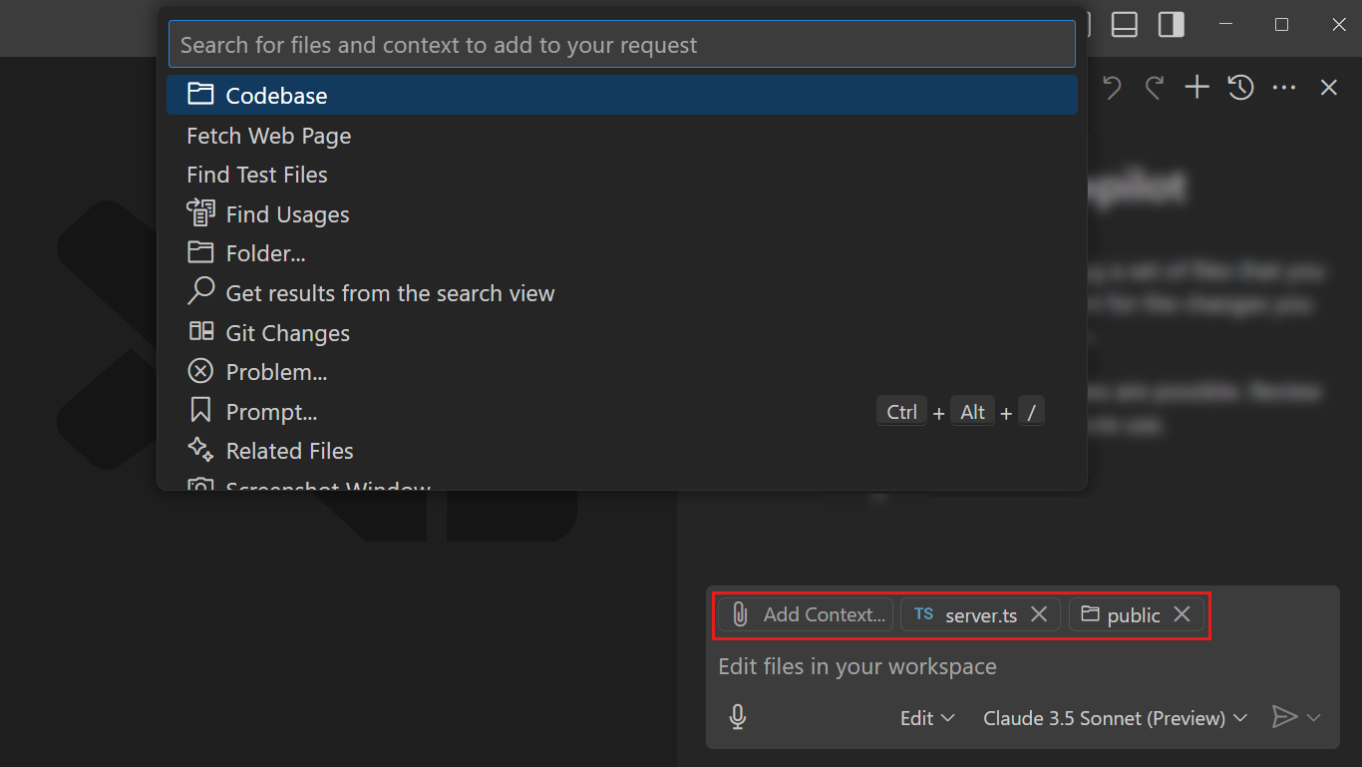

### Vision

Chat supports vision capabilities, which means you can **attach an image as context to your chat prompt and ask questions about it**. For example, attach a screenshot of a block of code and ask to explain it, or attach a sketch of a UI and ask agent mode to implement it.

You can attach images in multiple ways:

* Drag and drop images from your OS or from the Explorer view
* Paste an image from your clipboard
* Attach a screenshot of the VS Code window (select the paperclip📎button > Screenshot Window)

### Chat History

The Chat view is designed to be a **multi-turn conversation**. Copilot uses the history of the conversation as context to your current prompt. This means that you can ask follow-up questions or clarify your previous question without having to repeat the context.

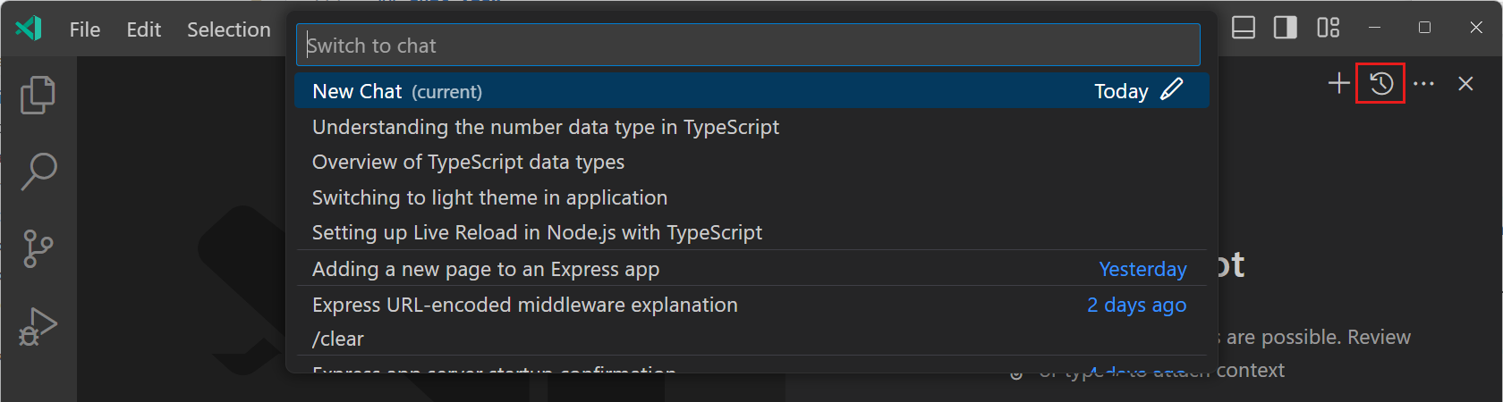

Usages:

* Create a new chat session by using the New Chat (+) button (Ctrl+L) in the Chat view.
* Access the **previous** chat sessions by using the Show Chats... button in the Chat view or by using the Chat: Show Chats... command in the Command Palette.
* **Export** all prompts and responses for a chat session in a JSON file with the Chat: Export Chat... command in the Command Palette.

### Reverting Previous Requests

Within a chat session, you can remove a specific prompt and the corresponding response from the conversation history of that session. Hover over the prompt and select the **X** control. Removing a request might be useful if you notice that the language model is **not providing relevant responses or is taking an unwanted direction**.

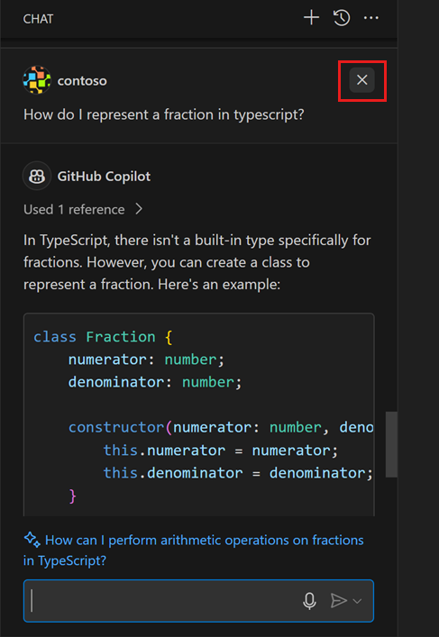

### Instruction Files

Copilot responses can be customized with custom instructions to **match your coding practices and project requirements**. These instructions are automatically **included in every chat request** and specialize multiple aspects such as *code genration*, *test generation*, *review selection*, *commit message generation*, etc.

Following is steps to configure instruction files:

1. Create instruction files.
2. Modify VSCode setting. Simply set the path for instruction files you created at the first step:

"github.copilot.chat.codeGeneration.instructions": [

{

"file": "general.instructions.md" // import instructions from file `general.instructions.md`

},

{

"file": "db.instructions.md" // import instructions from file `db.instructions.md`

}

],

"github.copilot.chat.testGeneration.instructions": [

// similar as above

],

"github.copilot.chat.reviewSelection.instructions": [

// similar as above

],

"github.copilot.chat.commitMessageGeneration.instructions": [

// similar as above

],

1. Add natural language instructions to the files. You can use the Markdown format.

The following example demonstrates custom instructions for *code generation*:

# Project coding standards

## TypeScript Guidelines

- Use TypeScript for all new code

- Follow functional programming principles where possible

- Use interfaces for data structures and type definitions

- Prefer immutable data (const, readonly)

- Use optional chaining (?.) and nullish coalescing (??) operators

## React Guidelines

- Use functional components with hooks

- Follow the React hooks rules (no conditional hooks)

- Use React.FC type for components with children

- Keep components small and focused

- Use CSS modules for component styling

## Naming Conventions

- Use PascalCase for component names, interfaces, and type aliases

- Use camelCase for variables, functions, and methods

- Prefix private class members with underscore (_)

- Use ALL_CAPS for constants

## Error Handling

- Use try/catch blocks for async operations

- Implement proper error boundaries in React components

- Always log errors with contextual information

**Tips:**

* Keep your instructions **short** and **self-contained**. Each instruction should be a single, simple statement. If you need to provide multiple pieces of information, use multiple instructions.
* Don't refer to external resources in the instructions, such as specific coding standards.
* Split instructions into **multiple files** and add multiple file references to your settings. This approach is useful for organizing instructions by topic or type of task.

**Notes:**

* Instructions are **only used in chat**, not for code suggestion/completion.

### Prompt Files

With prompt files, you can create reusable templates for common tasks in any chat mode (ask, edit, or agent mode).

VS Code supports two types of prompts:

#### Workspace Prompt Files

These are stored in a Markdown file within your workspace **and only available in that workspace**.

To use a workspace prompt file:

1. Set the chat.promptFiles setting to true.
2. Create a .prompt.md file in the .github/prompts directory (default directory for prompt files) of your workspace.

You can specify additional prompt file locations with the [chat.promptFilesLocations](vscode://settings/chat.promptFilesLocations) setting.

Alternatively, use the Chat: Create Prompt command from the Command Palette to create a prompt.

1. Author the chat prompt by using Markdown formatting.

**Tips:**

* Within a prompt file, reference additional workspace files as Markdown links ([index](../index.ts)), or as #file:../index.ts references within the prompt file.

#### User Prompt Files

These are stored in a Markdown file in your profile folder and **available for use across multiple workspaces**.

To use a user prompt file:

1. Select the Chat: Create User Prompt command from the Command Palette.
2. Enter a name for your prompt file.
3. Author the chat prompt by using Markdown formatting.

#### Use a Prompt File in Chat

To use a prompt file as a chat prompt, attach it to your chat request as context:

1. Open the Chat view in VS Code (Ctrl+Alt+I).
2. Select Attach Context in the chat input field, and then select Prompt....

Alternatively, use the Chat: Use Prompt command from the Command Palette (Ctrl+Shift+P).

1. Choose a prompt file from the Quick Pick to attach it to your chat request.
2. Optionally, attach additional context files required for the task or include more instructions in the chat prompt.

To use the prompt file as-is, send the chat prompt without any additional instructions.

### Chat Cheat Sheet

<https://docs.github.com/en/copilot/using-github-copilot/copilot-chat/github-copilot-chat-cheat-sheet?tool=vscode>

#### Slash Commands

They help avoid writing complex prompts for **common scenarios**.

List of commands:

|  |  |  |
| --- | --- | --- |
| **Command** | **Description** | **Example** |
| /help | Quick reference and basics of using GitHub Copilot. |  |
| /new | Create a new project. | /new python django web application |
| /clear | Start a new chat session. |  |
| /explain | Explain how the code in your active editor works. |  |
| /fix | Propose a fix for problems in the selected code. | /fix how would you improve this code? |
| /fixTestFailure | Find and fix a failing test. |  |
| /tests | Generate unit tests for the selected code.  Note: If you prefer to write tests before writing code (TDD), omit the /tests command | /tests using the Jest framework  /tests ensure the function rejects an empty list |

For examples:

* /new python django web application
* /fix how would you improve this code?
* /tests using the Jest framework

#### Chat Variables

They help **include specific context** in your prompt.

List of variables:

|  |  |  |
| --- | --- | --- |
| **Variable** | **Description** | **Example** |
| #block | Includes the current block of code in the prompt. |  |
| #class | Includes the current class in the prompt. |  |
| #comment | Includes the current comment in the prompt. |  |
| #file | Includes the current file's content in the prompt. | #file:gameReducer.js #file:gameInit.js how are these files related |
| #function | Includes the current function or method in the prompt. |  |
| #line | Includes the current line of code in the prompt. |  |
| #path | Includes the file path in the prompt. |  |
| #project | Includes the project context in the prompt. |  |
| #selection | Includes the currently selected text in the prompt. |  |
| #sym | Includes the current symbol in the prompt. |  |
| #editor |  |  |
| #codebase |  |  |
| #git |  |  |
| #terminalLastCommand |  |  |

#### Chat Participants

They are like **domain experts** who have a specialty that they can help you with.

List of participants:

|  |  |  |
| --- | --- | --- |
| **Variable** | **Description** | **Example** |
| @azure | Has context about Azure services and how to use, deploy and manage them. |  |
| @github | Allows you to use GitHub-specific Copilot skills.  Tip: Generate a list of currently available skills by asking Copilot: @github What skills are available? | @github Search the web to find the latest GPT model from OpenAI |
| @terminal | Has context about the VS Code terminal shell and its contents.  Use it when you want help creating or debugging terminal commands. | @terminal find the largest file in the src directory  @terminal #terminalLastCommand to explain the last command and any errors |
| @vscode | Has context about VS Code commands and features.  Use it when you want help with VS Code. | @vscode tell me how to debug a node.js app  @vscode how do I change my Visual Studio Code colors |
| @workspace | Has context about the code in your workspace.  Use it when you want Copilot to consider the structure of your project, how different parts of your code interact, or design patterns in your project. |  |

Chat examples:

* @workspace how are notifications scheduled

## Code Review

Copilot supports two types of review:

### Selection Review

**Highlight code** and ask for an initial review.

Steps:

1. In the command palette, search for and select GitHub Copilot: Review and Comment.

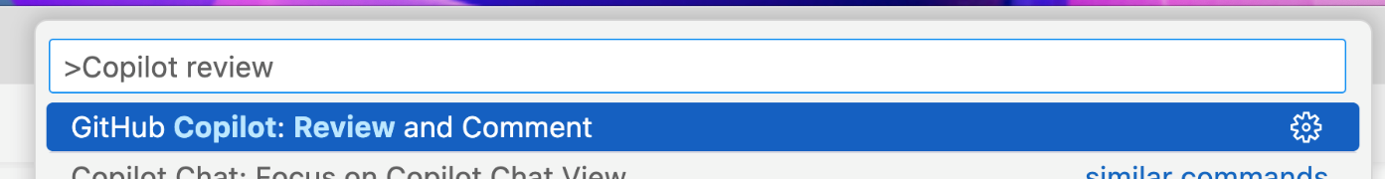

1. Wait for Copilot to review your changes. This usually takes less than 30 seconds.

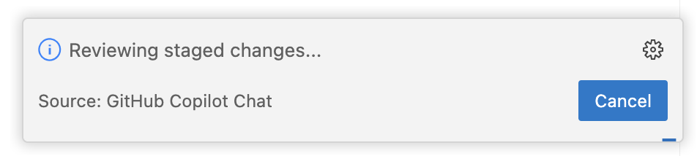

1. If Copilot has any comments, they will be shown inline in your file, and in the Problems tab.

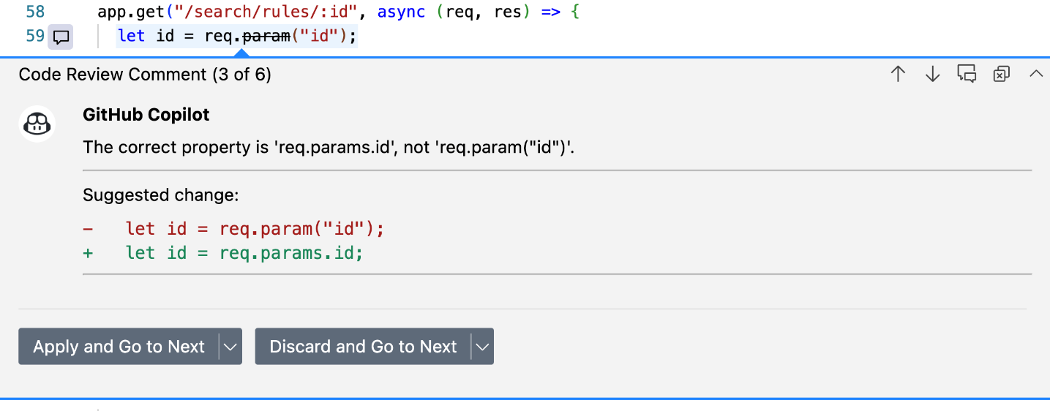

### Change Review

Request a deeper review of all your changes.

Steps:

1. In VS Code, switch to the Source Control tab.
2. To request a review on your unstaged changes, hover over Changes in the sidebar, and then click the  Copilot code review - Changes button.

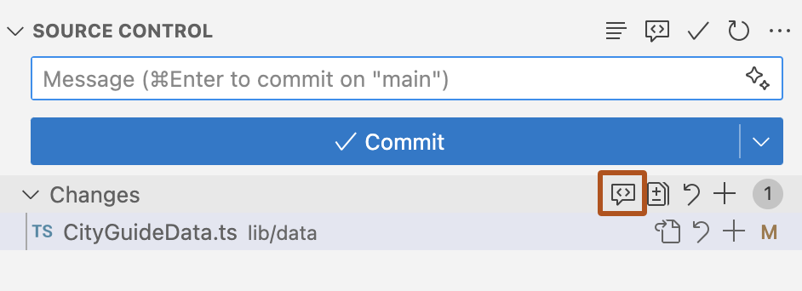

1. To request a review on your staged changes, hover over Staged Changes in the sidebar, and then click the  Copilot code review - Staged Changes button.
2. Wait for Copilot to review your changes. This usually takes less than 30 seconds.



1. If Copilot has any comments, they will be shown inline in your file(s), and in the Problems tab.

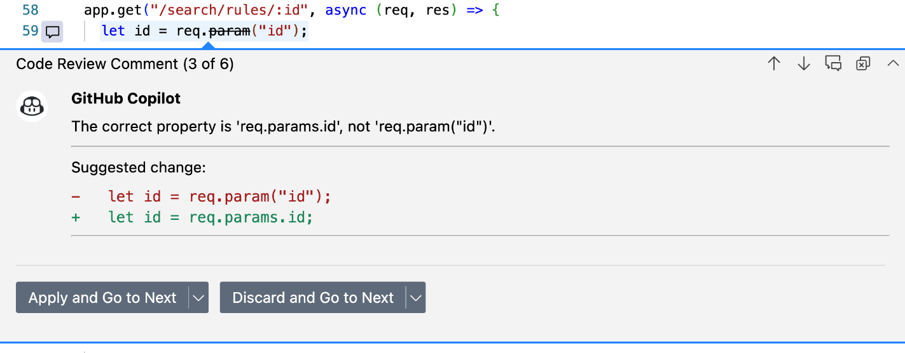

## Smart Actions

### Generating Commit Messages

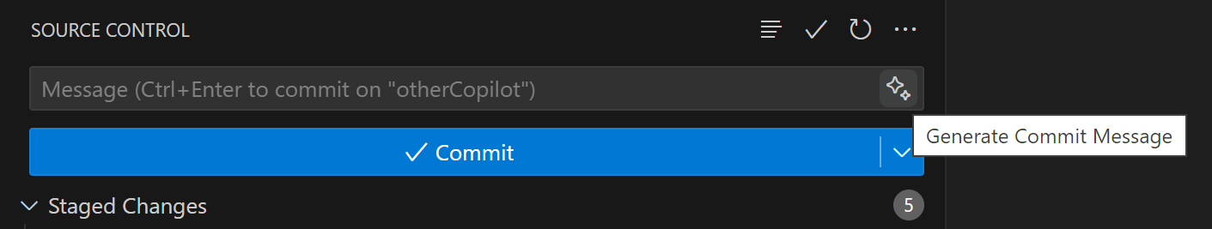

### Renaming Symbols

When you rename a symbol in your code, Copilot suggests a new name based on the context of the symbol and the codebase.

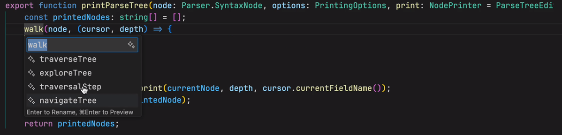

### Fixing / Explanaing Code

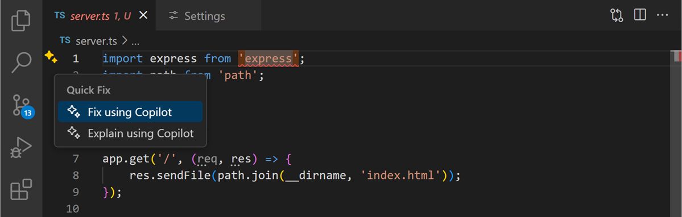

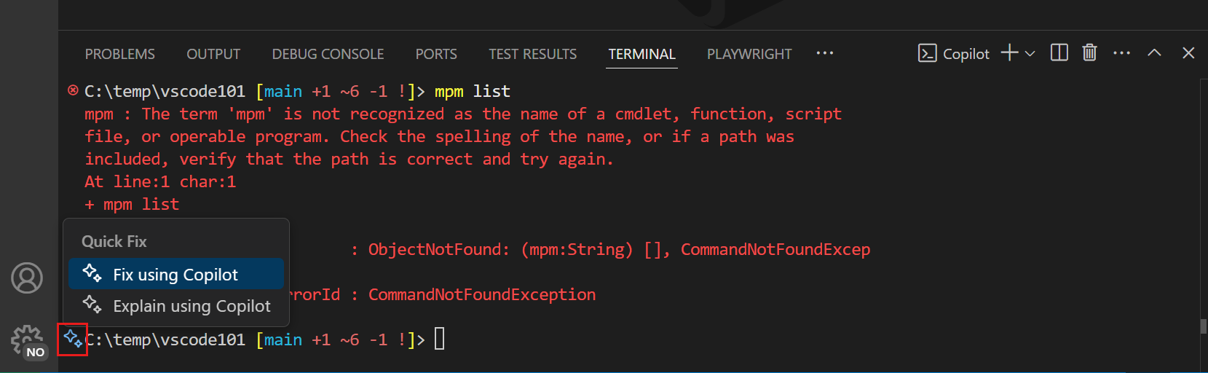

### Semantic Search Results

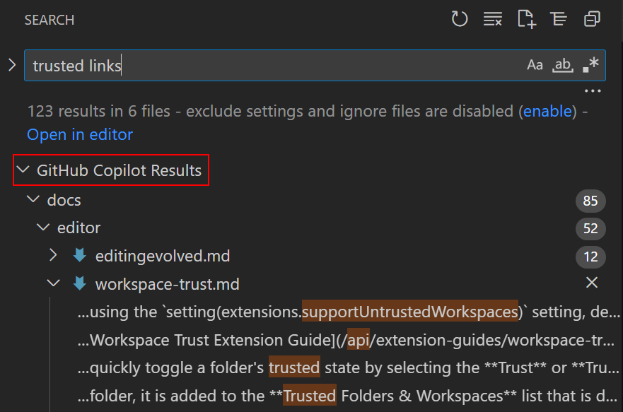

## Agent Mode

 This is the next evolution in AI-assisted coding.

## Additional Commands

### Debugging

<https://code.visualstudio.com/docs/copilot/guides/debug-with-copilot>

## Windows Terminal

First [install Windows Terminal Canary](https://github.com/microsoft/terminal?tab=readme-ov-file#installing-windows-terminal-canary).

### Getting Command Explanations and Suggestions

In the Terminal Chat chat window, type a question (for example, how do i list all markdown files in my directory) then press Enter.

Copilot's answer is displayed below your question.

Click on an answer to insert it to the command line.

## Writing Good Prompts

### Start General, then Get Specific

First give Copilot a broad description of the goal or scenario. Then list any specific requirements.

|  |  |
| --- | --- |
| DON'T | DO |
| - Write a function that return true if a positive integer is prime. | - Write a function that tells me if a number is prime.  - The function should take an integer and return true if the integer is prime.  - The function should error if the input is not a positive integer. |

### Break Complex Tasks into Simpler Tasks

Break complex, large task into multiple simple, small tasks.

|  |  |
| --- | --- |
| DON'T | DO |
| - Generate a word search puzzle. | - Write a function to generate a 10 by 10 grid of letters.  - Write a function to find all words in a grid of letters, given a list of valid words.  - Write a function that uses the previous functions to generate a 10 by 10 grid of letters that contains at least 10 words.  - Update the previous function to print the grid of letters and 10 random words from the grid. |

### Give Examples

Examples really help Copilot understand what you want.

|  |
| --- |
| Write a function that finds all dates in a string and returns them in an array. Dates can be formatted like:   * 05/02/24 * 05/02/2024 * 5/2/24 * 5/2/2024 * 05-02-24 * 05-02-2024 * 5-2-24 * 5-2-2024   Example:   * Input: "I have a dentist appointment on 11/14/2023 and book club on 12-1-23". Output: ["11/14/2023", "12-1-23"] |

**Tips**:

* Unit tests can also serve as examples. Before writing your function, you can use Copilot to write unit tests for the function. Then, you can ask Copilot to write a function described by those unit tests.

### Avoid Ambiguity

Avoid ambiguous terms.

|  |  |
| --- | --- |
| DON'T | DO |
| - What does this do? | - What does the createUser function do? |
| - What does the code in your last response do? |

Ambiguity can also apply to libraries:

* If you are using an uncommon library, describe what the library does.
* If you want to use a specific library, set the import statements at the top of the file or specify what library you want to use.

### Experiment and Iterate

If you **don’t get the result that you want, iterate on your prompt and try again.**

* If you are using Copilot to get suggestions as you code, you can delete the suggestion entirely and start over. Or you can keep the suggestion and request modifications.
* If you are using Copilot Chat, you can reference the previous response in your next request. Or, you can delete the previous response and start over.

### Keep History Relevant

Copilot Chat uses the chat **history to get context** about your request. To give Copilot only the relevant history:

* Use threads to start a new conversation for a new task.
* Delete requests that are no longer relevant or that didn’t give you the desired result.

# Choosing AI Model for GitHub Copilot

<https://github.blog/ai-and-ml/github-copilot/which-ai-model-should-i-use-with-github-copilot/>

<https://docs.github.com/en/copilot/using-github-copilot/ai-models/choosing-the-right-ai-model-for-your-task>

# References

Official guide lines from GitHub and VSCode:

* <https://github.com/features/copilot/tutorials>
* <https://docs.github.com/en/copilot>

Changelog:

* <https://github.blog/changelog/label/copilot/>